External API consumed in RAP:
https://github.com/developedbysom/RAP-Extension/blob/master/SourceCodeLib/ZCL_CE_GET_PRODUCTS.abap

https://youtu.be/9OuJ8e1k2Zs - in series need to check
Go to your package -- > right click select the Business Services New select service consumption model.
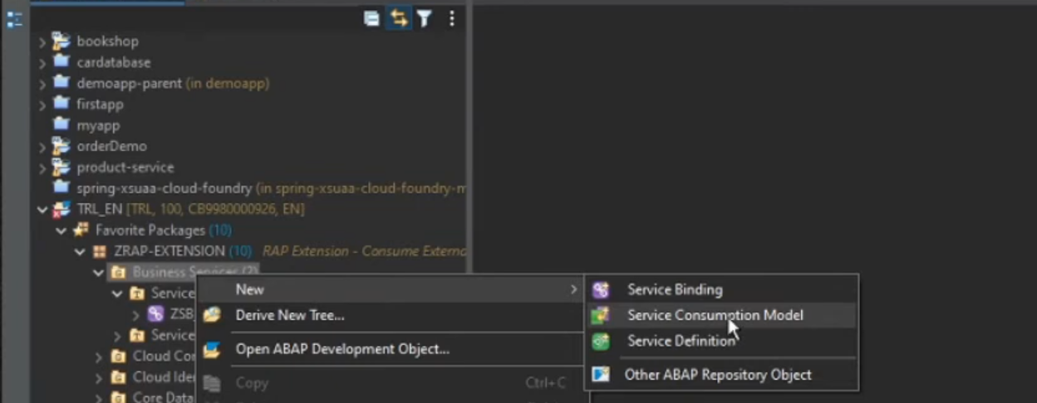
Next screens create the service consumption model screen appears provide inputs.
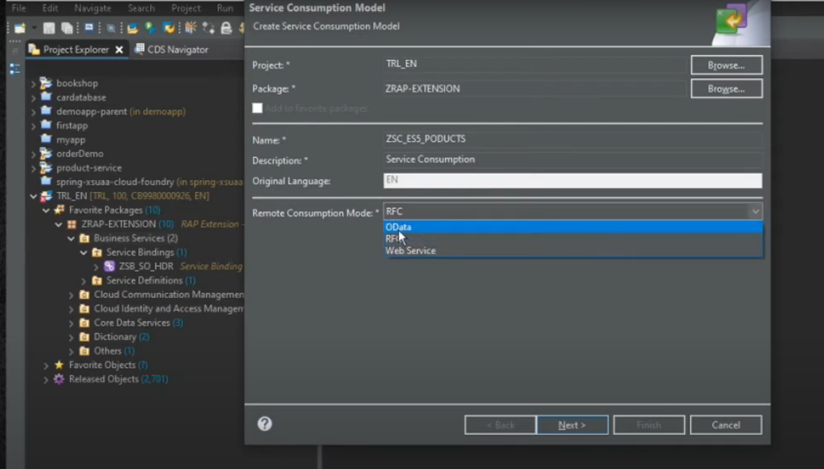
Remote consumption model- Odata
Webservice – SOAP call.
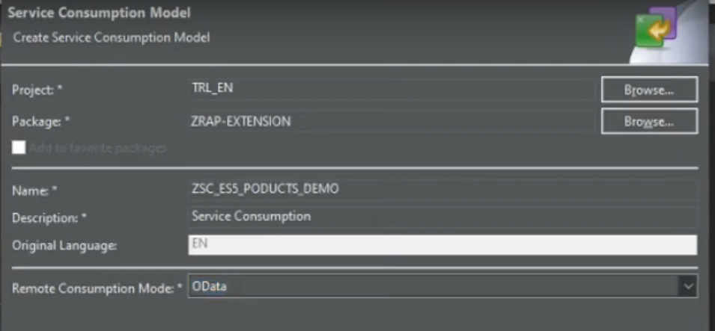
Click on next button
Next point is upload the metadata.
Next screen, upload the metadata.
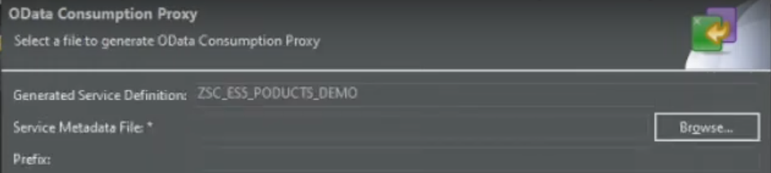
Click on browse to search the metdata (*.edmx or *.xml) select the necessary metadata file click on open.
Add the prefix :ZZCE_SO_
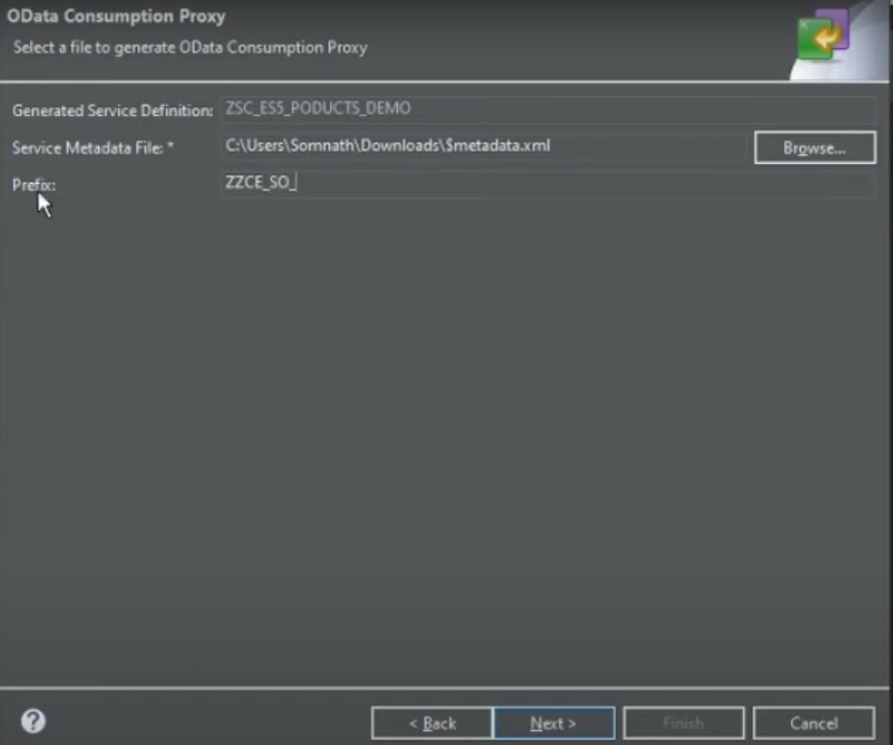
Click on next.
In next screen it will define the new entity and new artifacts.
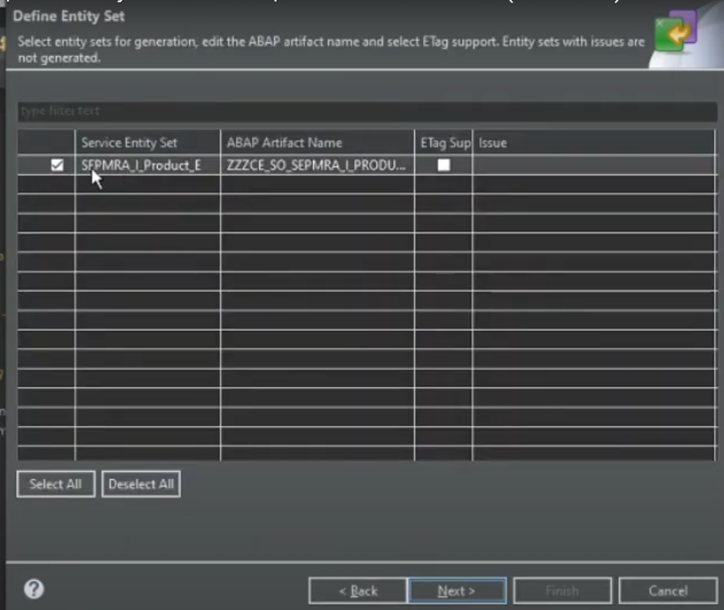
Default names get it from metadata.
Click on next
In next screen appear for generated service list.
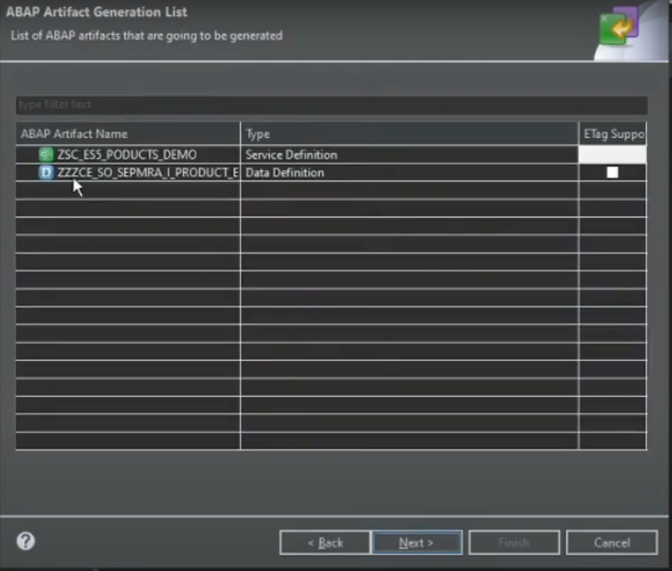
Two artifacts are created.
- <prefix>_<service entity set> Data definition.
- ZSC_ES5_PRODUCTS_DEMO service name( service model name) previously assigned.
Now save it in one tr.
Click on finish
Now service consumption model created please check below screen shot.
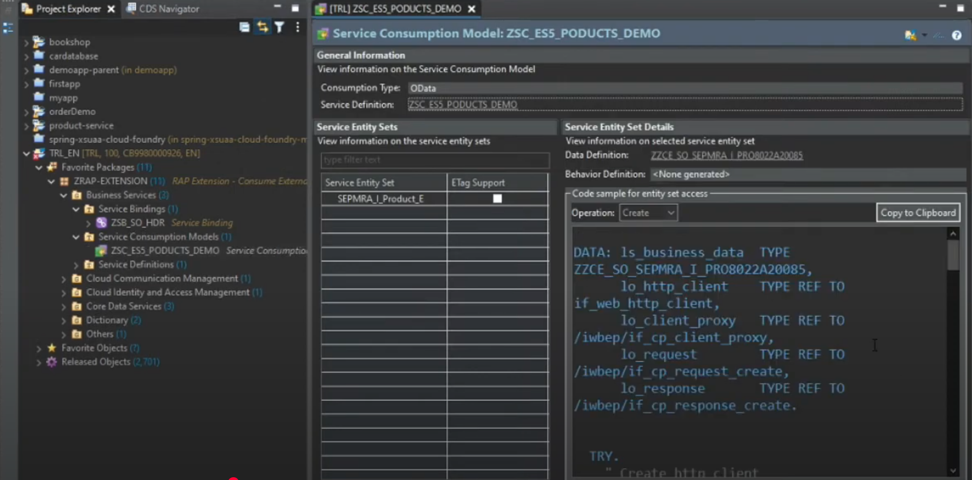
Here we have the different codes that will generate for based on operations. You have to select and system will show the specific method.
Create – post operation.
Read- get – single data
Read list – get- filter
Update – update operation
Delete – delete operation
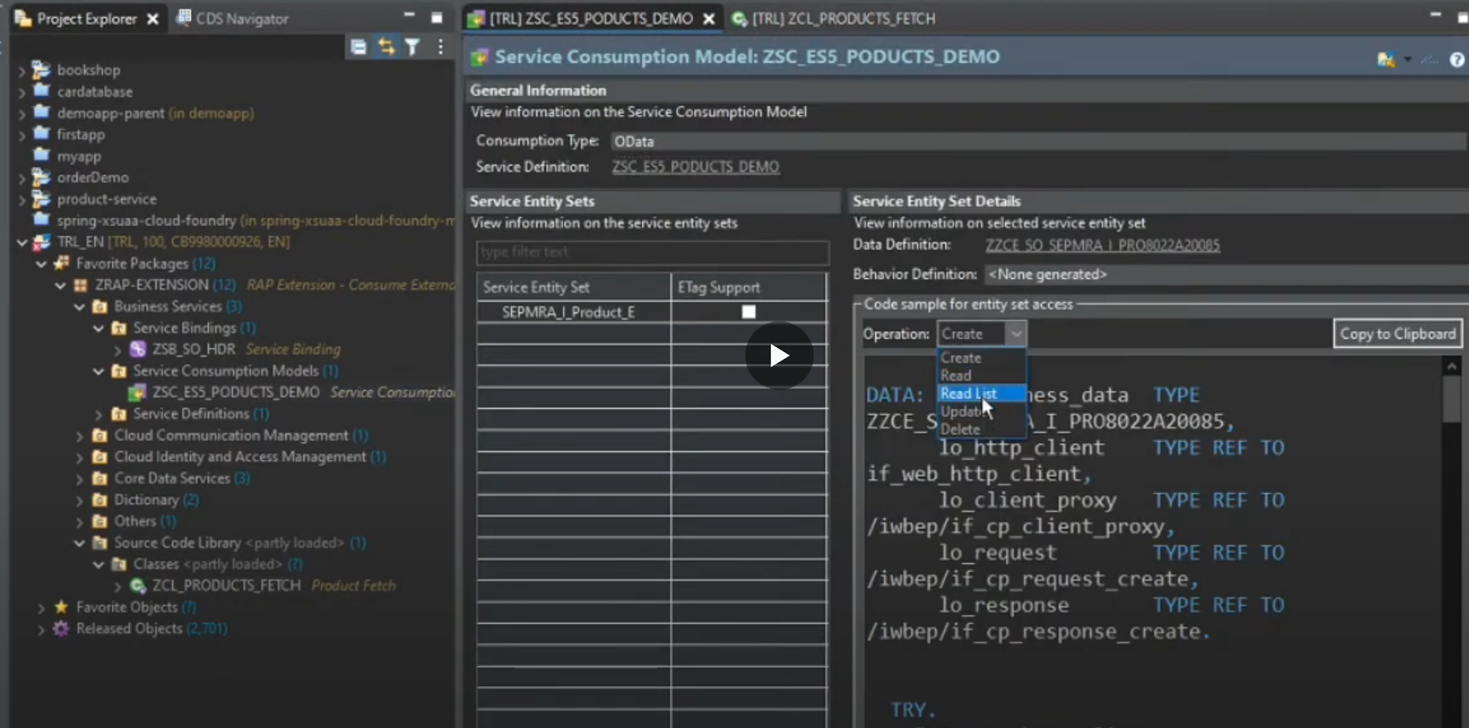
Now create the new class. Class ZCL_PRODUCTS_FETCH -07:15
Git hub: developedbysa(o)m/RAP-extension
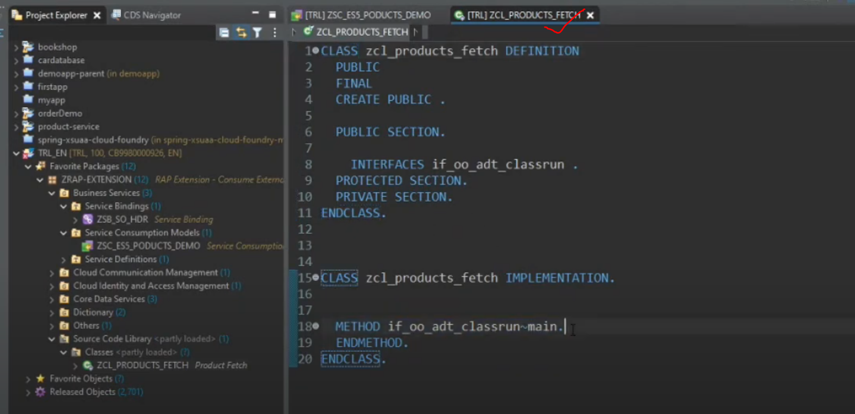
For query operation : use the interface- if_rap_query_provider
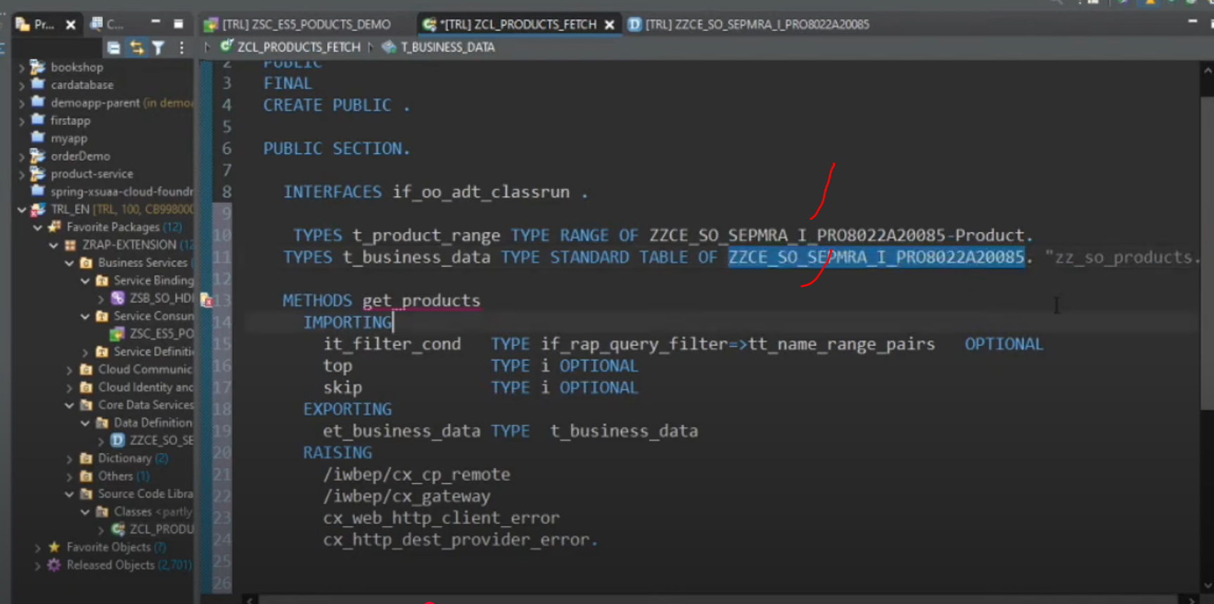
Here get_products method not implemented, lets implement that.
Add below code in get_products method.

In main() method code.
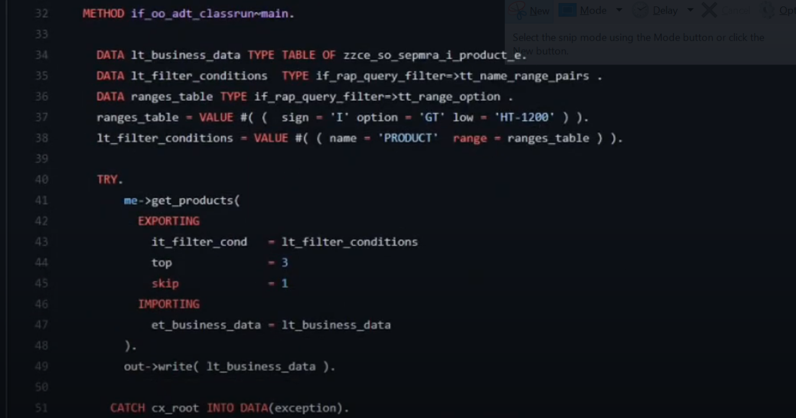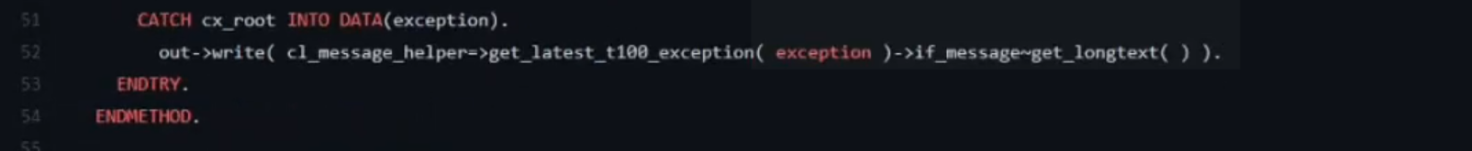
In get_products() method code:
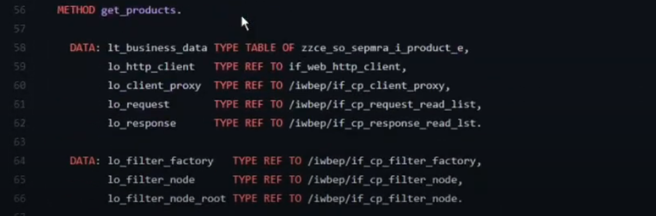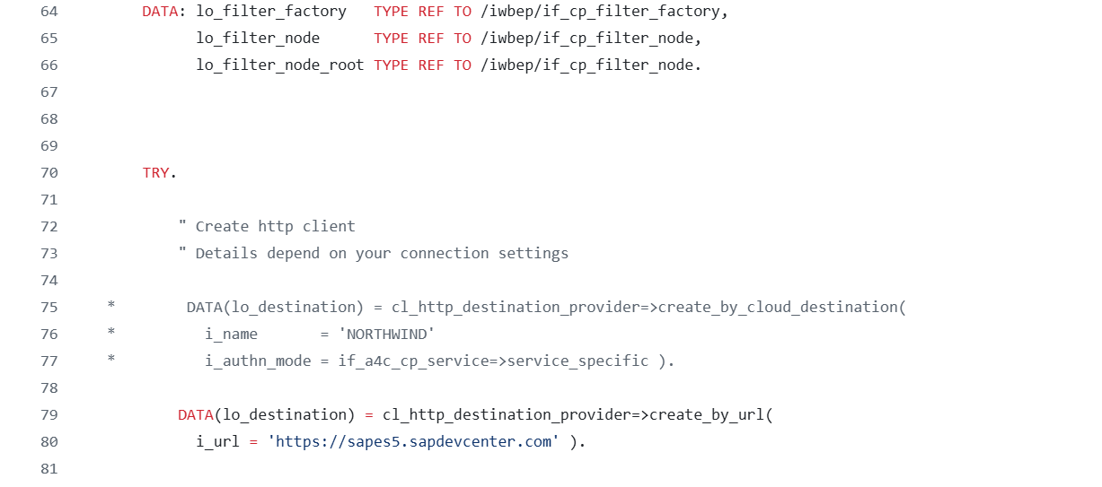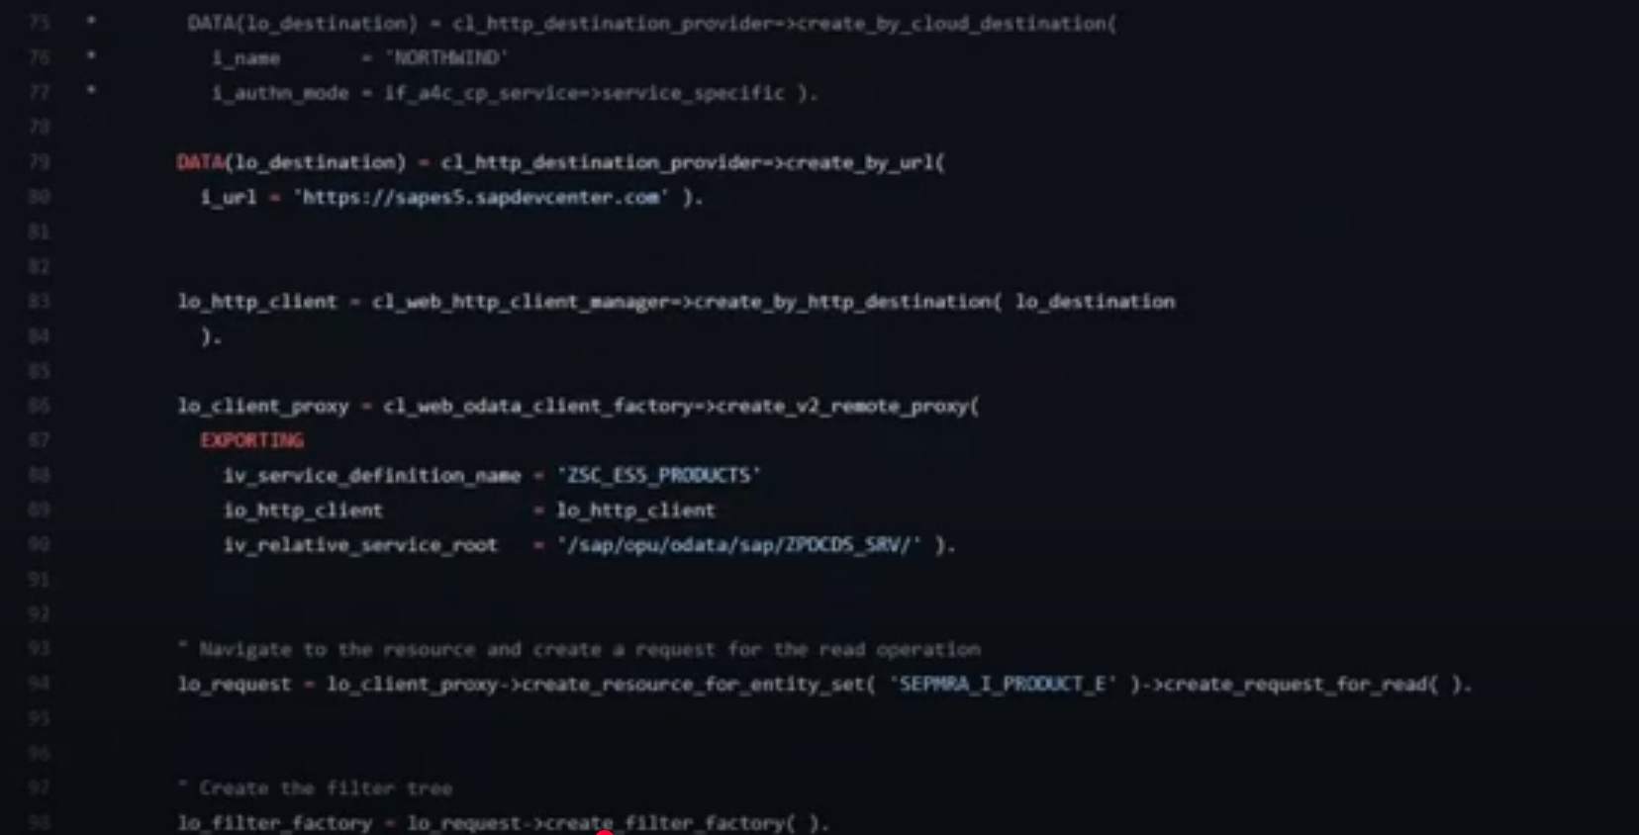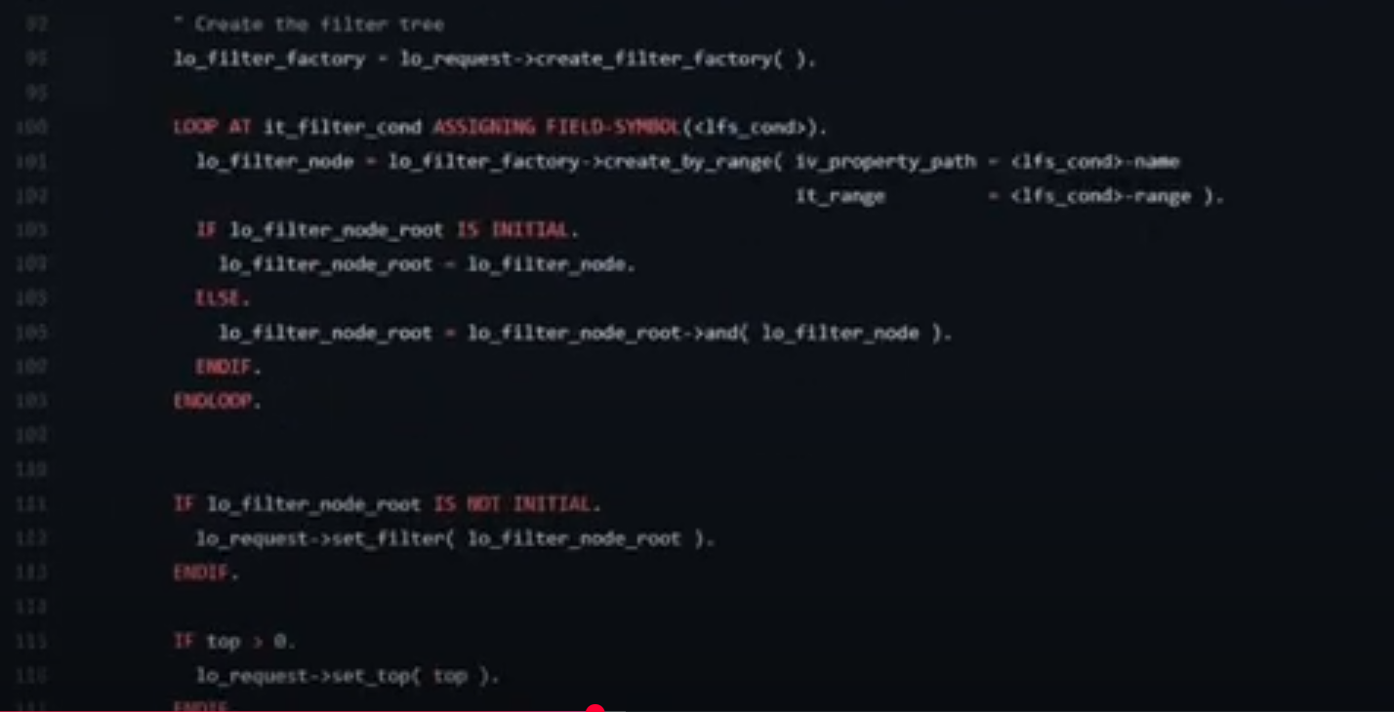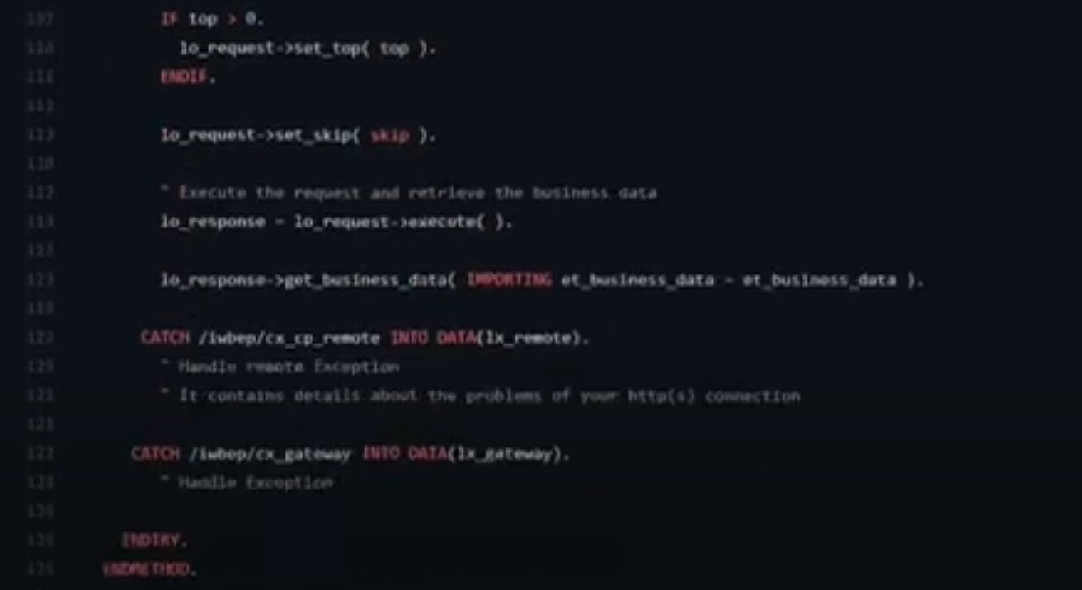
Now linkage the class to custom entity:
Go to custom entity: here custom entity is ZCE_PRODUCTS_ES5_DEMO
- Use the anootation for linkage in custom entity:
@ObjectModel.query.implementedBy: ‘ABAP:ZCL_PRODUCTS_FETCH’
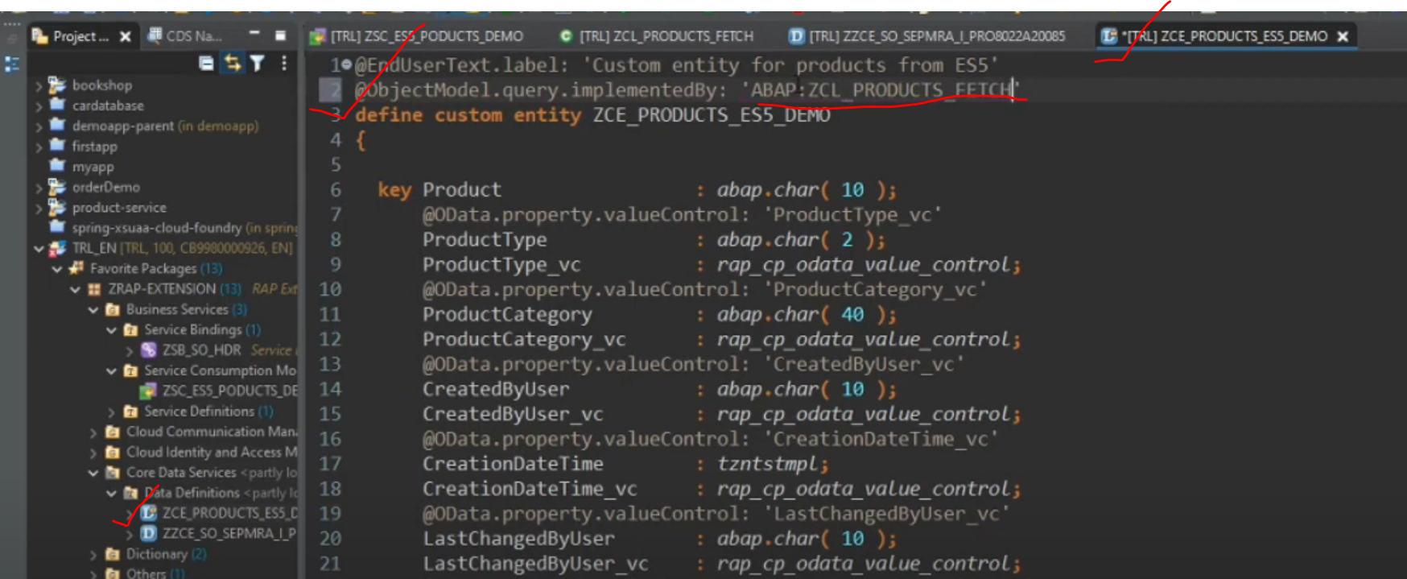
Now custom entity linked to the class.
Activate it again.
Now linkage has done but class not able to listen the action, when user click on F4 and click on the screen. For this we need to implement the one more query kind of interface to implement with in our class.
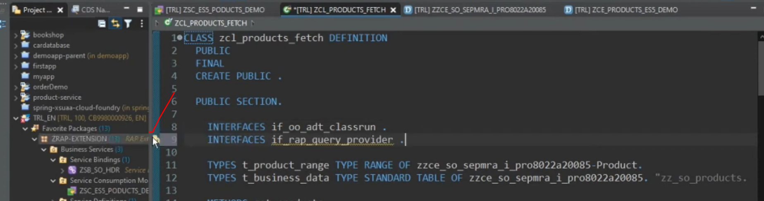
For query provider we have to use the interface: interfaces: if_Rap_query_provider.
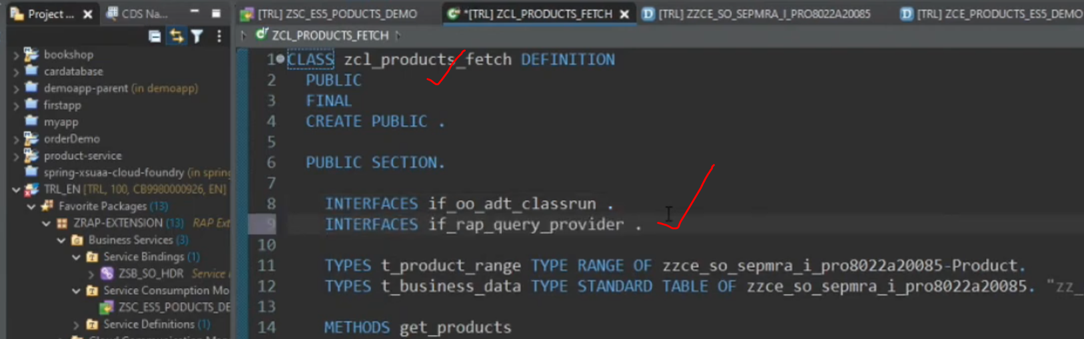
Now implement this and query provider interface have the only “select” method. So we have to implement
If it is not implemented, it will show as the to implement the method and click it.
Double click it. It is implement in class.
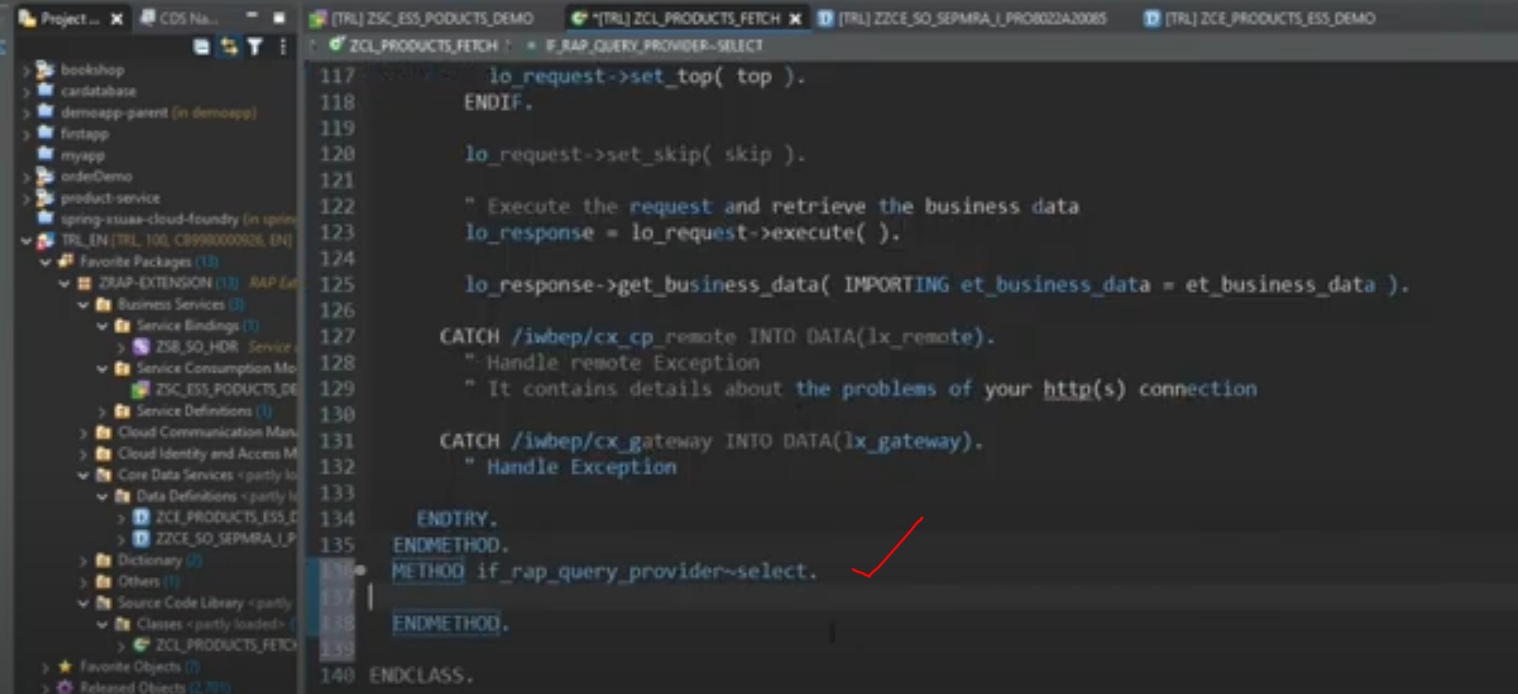
Method select- source code:
METHOD if_rap_query_provider~select.

DATA business_data TYPE TABLE OF zzce_so_sepmra_i_product_e.
DATA(top) = io_request->get_paging( )->get_page_size( ).
DATA(skip) = io_request->get_paging( )->get_offset( ).
DATA(requested_fields) = io_request->get_requested_elements( ).
DATA(sort_order) = io_request->get_sort_elements( ).

TRY.
DATA(filter_condition) = io_request->get_filter( )->get_as_ranges( ).

get_products(
EXPORTING
it_filter_cond = filter_condition
top = CONV i( top )
skip = CONV i( skip )
IMPORTING
et_business_data = business_data
).
io_response->set_total_number_of_records( lines( business_data ) ).
io_response->set_data( business_data ).

CATCH cx_root INTO DATA(exception).
DATA(exception_message) = cl_message_helper=>get_latest_t100_exception(
exception )->if_message~get_longtext( ).
ENDTRY.
ENDMETHOD.

ENDCLASS.
Get_products and select method total code:
CLASS zcl_ce_get_products DEFINITION
PUBLIC
FINAL
CREATE PUBLIC .

PUBLIC SECTION.

INTERFACES if_oo_adt_classrun .
INTERFACES if_rap_query_provider .

TYPES t_product_range TYPE RANGE OF zzce_so_sepmra_i_product_e-Product.
TYPES t_business_data TYPE STANDARD TABLE OF zzce_so_sepmra_i_product_e. "zz_so_products.

METHODS get_products
IMPORTING
it_filter_cond TYPE if_rap_query_filter=>tt_name_range_pairs OPTIONAL
top TYPE i OPTIONAL
skip TYPE i OPTIONAL
EXPORTING
et_business_data TYPE t_business_data
RAISING
/iwbep/cx_cp_remote
/iwbep/cx_gateway
cx_web_http_client_error
cx_http_dest_provider_error.
PROTECTED SECTION.
PRIVATE SECTION.
ENDCLASS.
CLASS zcl_ce_products IMPLEMENTATION.

METHOD if_oo_adt_classrun~main.

DATA lt_business_data TYPE TABLE OF zzce_so_sepmra_i_pro8022a20085.
DATA lt_filter_conditions TYPE if_rap_query_filter=>tt_name_range_pairs .
DATA ranges_table TYPE if_rap_query_filter=>tt_range_option .
ranges_table = VALUE #( ( sign = 'I' option = 'GT' low = 'HT-1200' ) ).
lt_filter_conditions = VALUE #( ( name = 'PRODUCT' range = ranges_table ) ).

TRY.
me->get_products(
EXPORTING
it_filter_cond = lt_filter_conditions
top = 3
skip = 1
IMPORTING
et_business_data = lt_business_data
).
out->write( lt_business_data ).

CATCH cx_root INTO DATA(exception).
out->write( cl_message_helper=>get_latest_t100_exception( exception )->if_message~get_longtext( ) ).
ENDTRY.
ENDMETHOD.

METHOD get_products.

DATA: lt_business_data TYPE TABLE OF zzce_so_sepmra_i_pro8022a20085.,
lo_http_client TYPE REF TO if_web_http_client,
lo_client_proxy TYPE REF TO /iwbep/if_cp_client_proxy,
lo_request TYPE REF TO /iwbep/if_cp_request_read_list,
lo_response TYPE REF TO /iwbep/if_cp_response_read_lst.

DATA: lo_filter_factory TYPE REF TO /iwbep/if_cp_filter_factory,
lo_filter_node TYPE REF TO /iwbep/if_cp_filter_node,
lo_filter_node_root TYPE REF TO /iwbep/if_cp_filter_node.

TRY.

" Create http client
" Details depend on your connection settings

* DATA(lo_destination) = cl_http_destination_provider=>create_by_cloud_destination(
* i_name = 'NORTHWIND'
* i_authn_mode = if_a4c_cp_service=>service_specific ).

DATA(lo_destination) = cl_http_destination_provider=>create_by_url(
i_url = 'https://sapes5.sapdevcenter.com' ).

lo_http_client = cl_web_http_client_manager=>create_by_http_destination( lo_destination
).

lo_client_proxy = cl_web_odata_client_factory=>create_v2_remote_proxy(
EXPORTING
iv_service_definition_name = 'ZSC_ES5_PRODUCTS'
io_http_client = lo_http_client
iv_relative_service_root = '/sap/opu/odata/sap/ZPDCDS_SRV/' ).

" Navigate to the resource and create a request for the read operation
lo_request = lo_client_proxy->create_resource_for_entity_set( 'SEPMRA_I_PRODUCT_E' )->create_request_for_read( ).

" Create the filter tree
lo_filter_factory = lo_request->create_filter_factory( ).

LOOP AT it_filter_cond ASSIGNING FIELD-SYMBOL(<lfs_cond>).
lo_filter_node = lo_filter_factory->create_by_range( iv_property_path = <lfs_cond>-name
it_range = <lfs_cond>-range ).
IF lo_filter_node_root IS INITIAL.
lo_filter_node_root = lo_filter_node.
ELSE.
lo_filter_node_root = lo_filter_node_root->and( lo_filter_node ).
ENDIF.
ENDLOOP.

IF lo_filter_node_root IS NOT INITIAL.
lo_request->set_filter( lo_filter_node_root ).
ENDIF.

IF top > 0.
lo_request->set_top( top ).
ENDIF.

lo_request->set_skip( skip ).

" Execute the request and retrieve the business data
lo_response = lo_request->execute( ).

lo_response->get_business_data( IMPORTING et_business_data = et_business_data ).

CATCH /iwbep/cx_cp_remote INTO DATA(lx_remote).
" Handle remote Exception
" It contains details about the problems of your http(s) connection

CATCH /iwbep/cx_gateway INTO DATA(lx_gateway).
" Handle Exception

ENDTRY.
ENDMETHOD.

METHOD if_rap_query_provider~select.

DATA business_data TYPE TABLE OF zzce_so_sepmra_i_pro8022a20085..
DATA(top) = io_request->get_paging( )->get_page_size( ).
DATA(skip) = io_request->get_paging( )->get_offset( ).
DATA(requested_fields) = io_request->get_requested_elements( ).
DATA(sort_order) = io_request->get_sort_elements( ).

TRY.
DATA(filter_condition) = io_request->get_filter( )->get_as_ranges( ).

get_products(
EXPORTING
it_filter_cond = filter_condition
top = CONV i( top )
skip = CONV i( skip )
IMPORTING
et_business_data = business_data
).
io_response->set_total_number_of_records( lines( business_data ) ).
io_response->set_data( business_data ).

CATCH cx_root INTO DATA(exception).
DATA(exception_message) = cl_message_helper=>get_latest_t100_exception(
exception )->if_message~get_longtext( ).
ENDTRY.
ENDMETHOD.

ENDCLASS.

Now add the annotations for F4 help for user action on top of specific field.
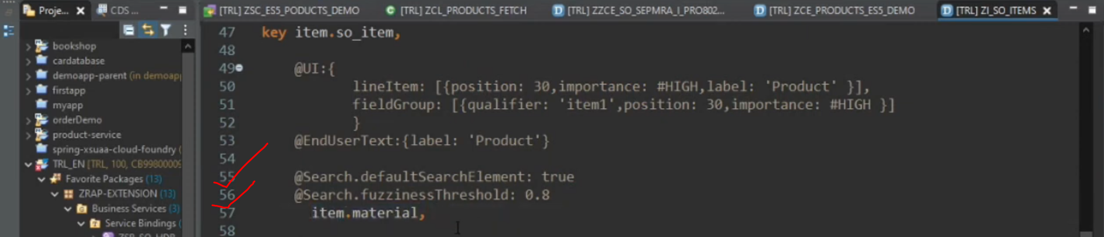
For F4 help
Additional binding: when selecting the ‘material on F4 help, we have to automatically fill with product category and supplier.
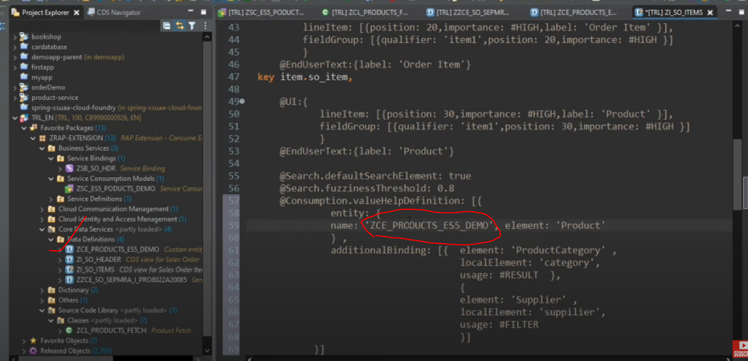
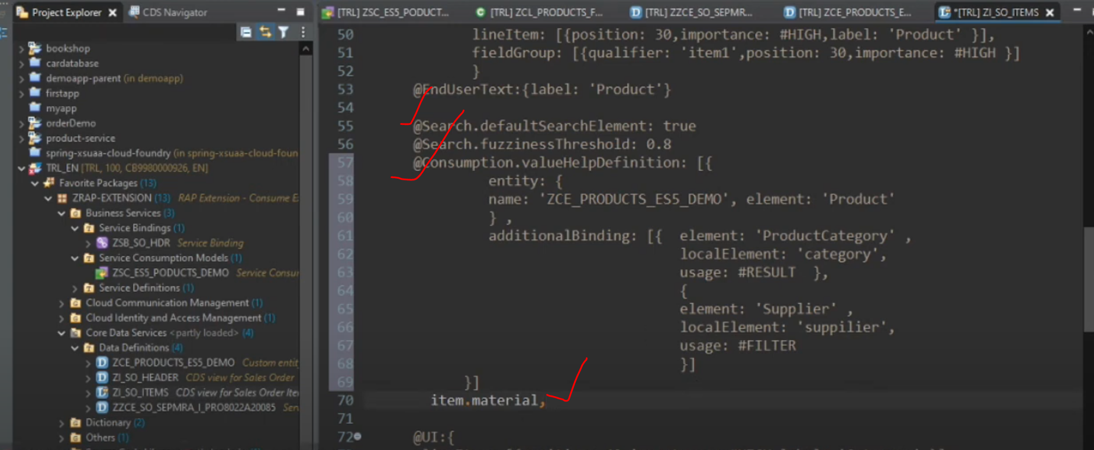
Now add search help for supplier and product category
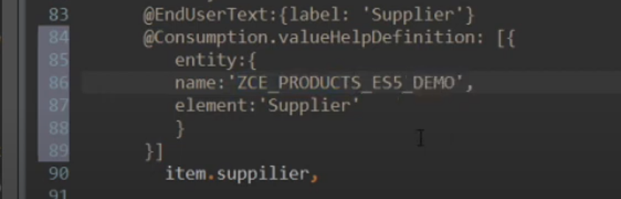
Custom entity we have created that is having the link annotation having the class and class is able to fetch the data from the api.
Now activate that.
Explanation: obviously we will expect the custom entity is available in our service consumption, what happened when generate the service consumption model and it has also generate the service definition and inside the service definition, custom entity also added inside the service definition.
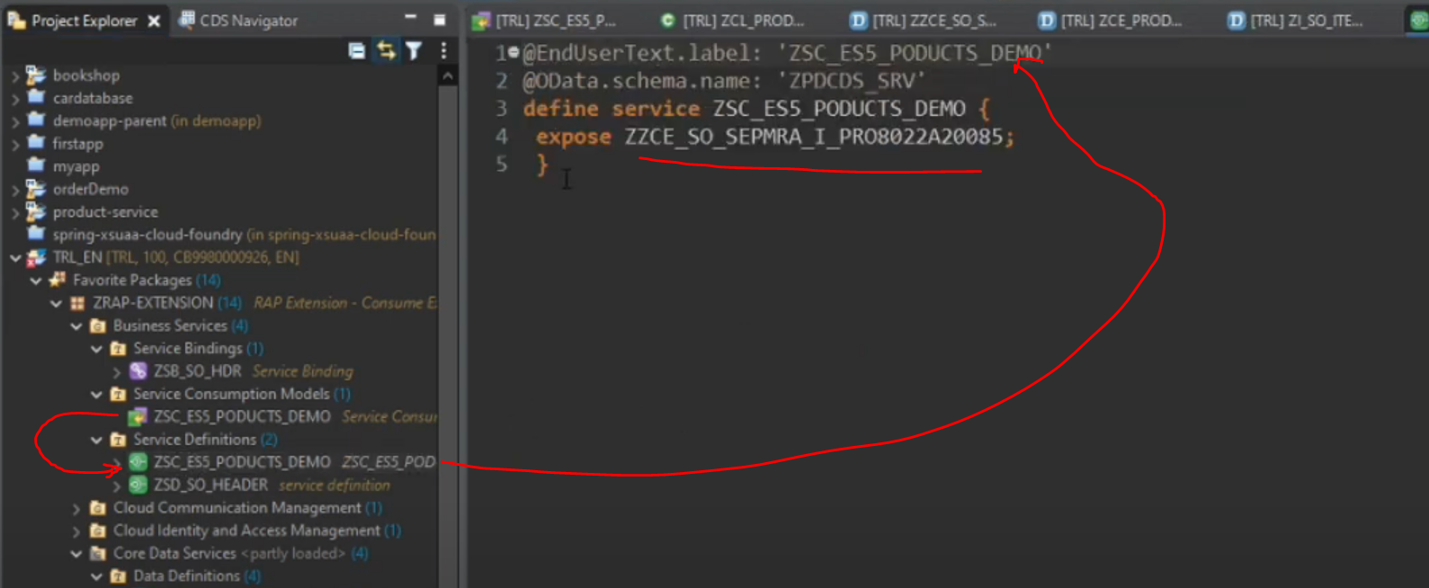
Service binding:
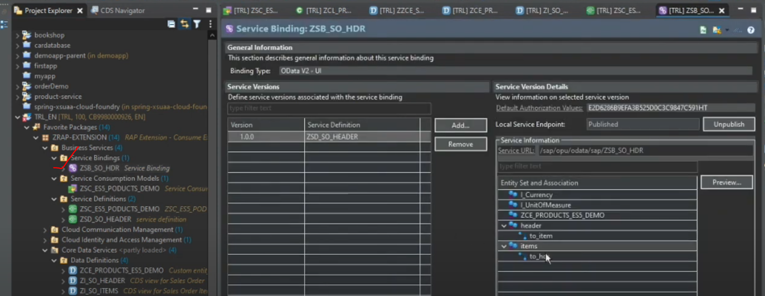
Now custom entity available. – ZCE_PRODUCTS_ES5_DEMO( Custom Entity )

Testing:
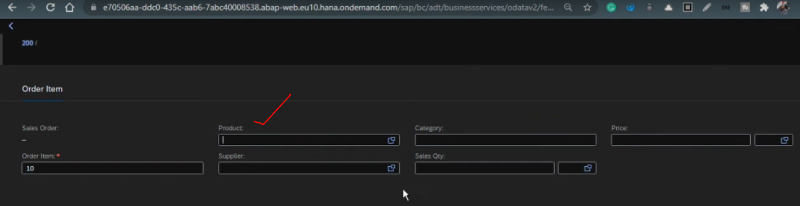
Click on F4 help for products
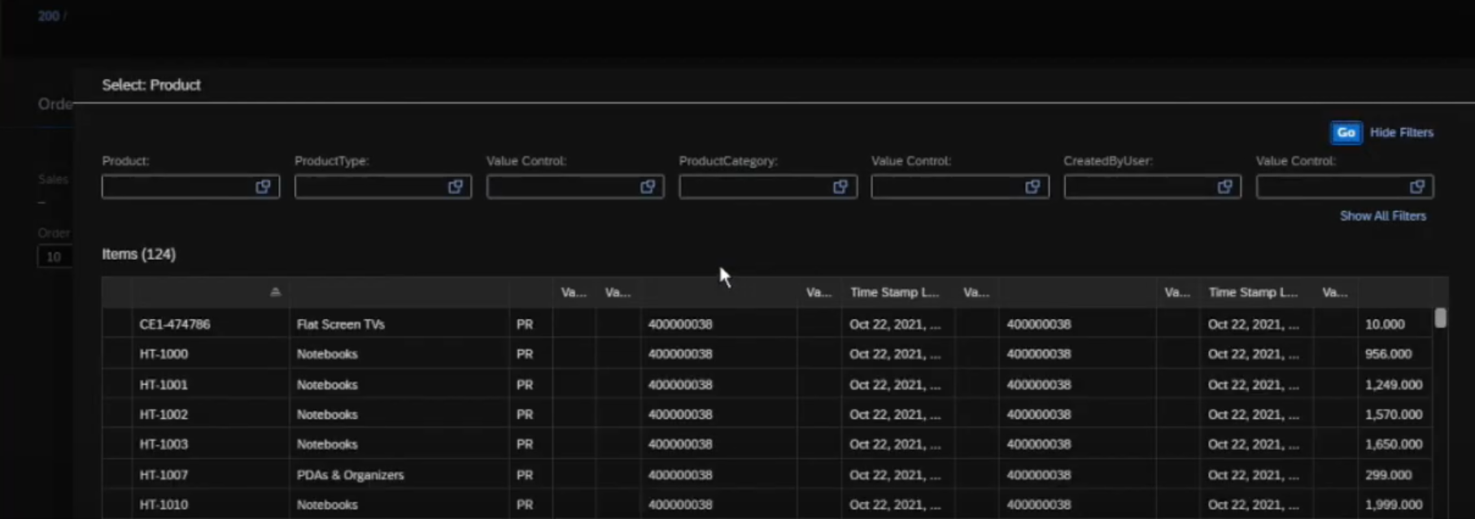
Select anything
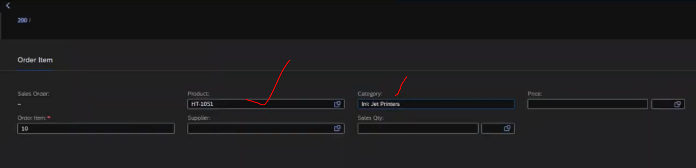
Now search on supplier
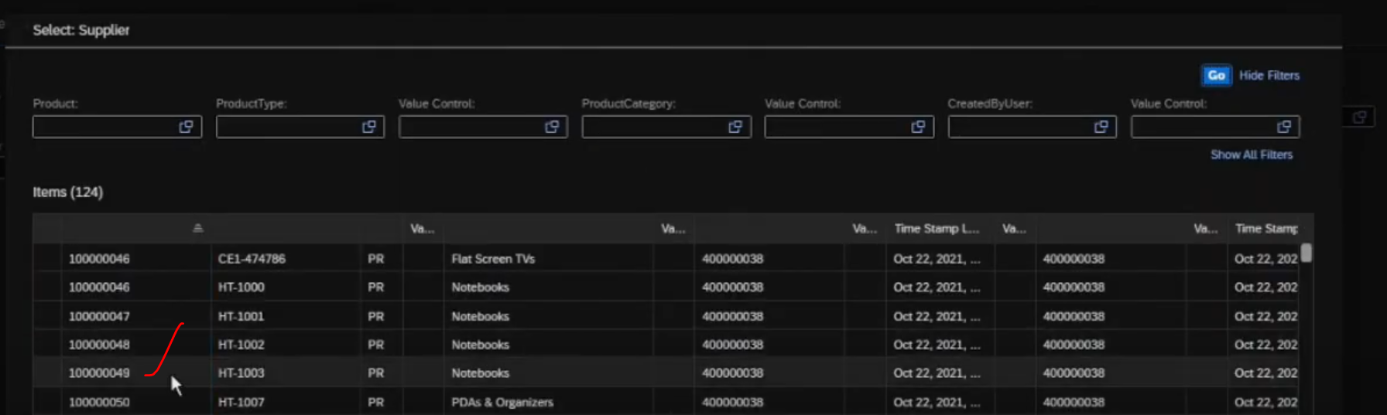
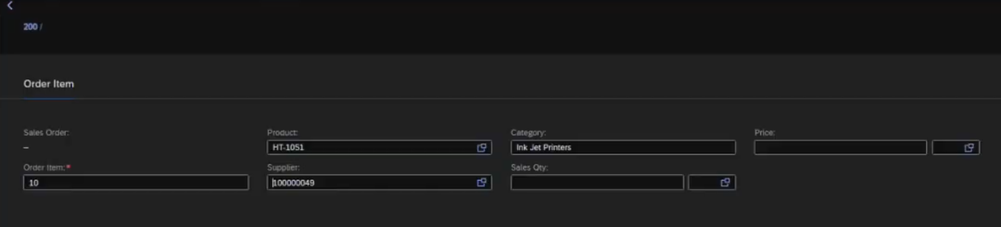
And now again choose the product.
And now products are filtered based on Supplier:
